**MAZE SOLVING BOT(Wall-Follower type)**

**Parts List:**

1. Arduino UNO
2. 12v DC motors (x2)
3. Wheels (x2)
4. Motor Driver (L298N)
5. Distance Sensor (Ultra Sonic)x3
6. Wires (Jumper wires 1-pin male-male && male-female)
7. 6V Li-ion Battery x2

**Tools List:**

1. Battery Charger
2. Cardboard Sheet
3. Glue Gun

Parts

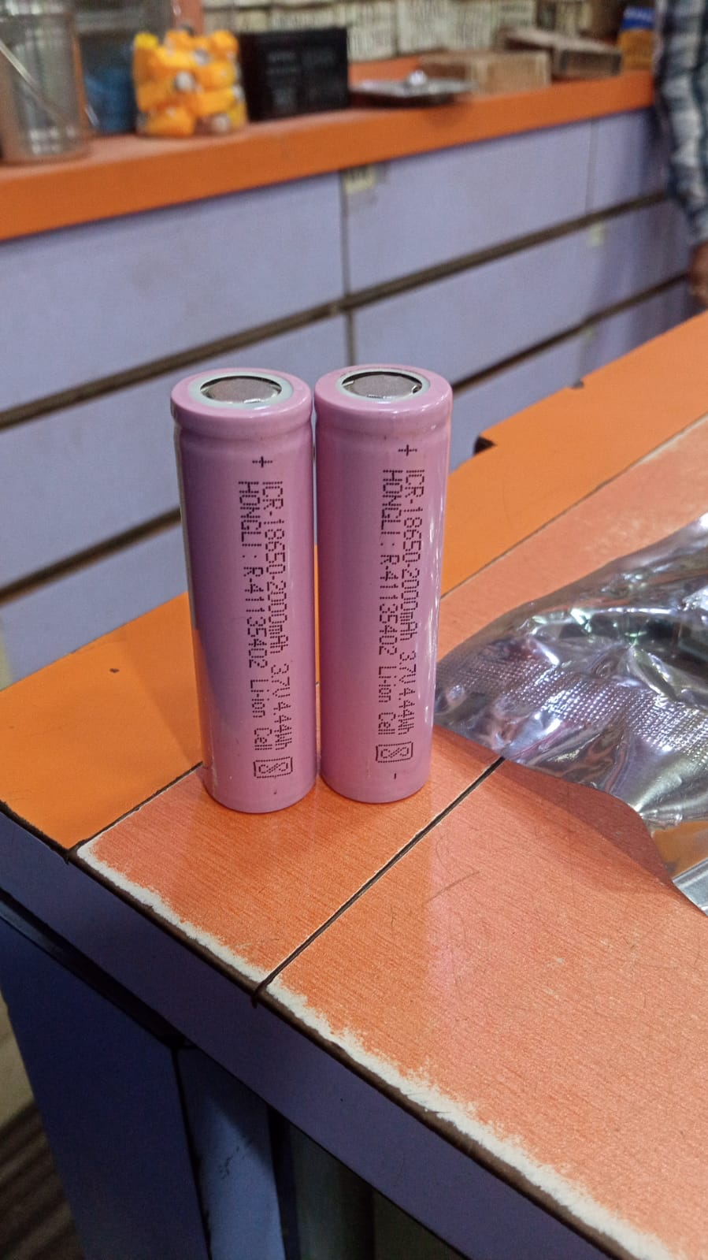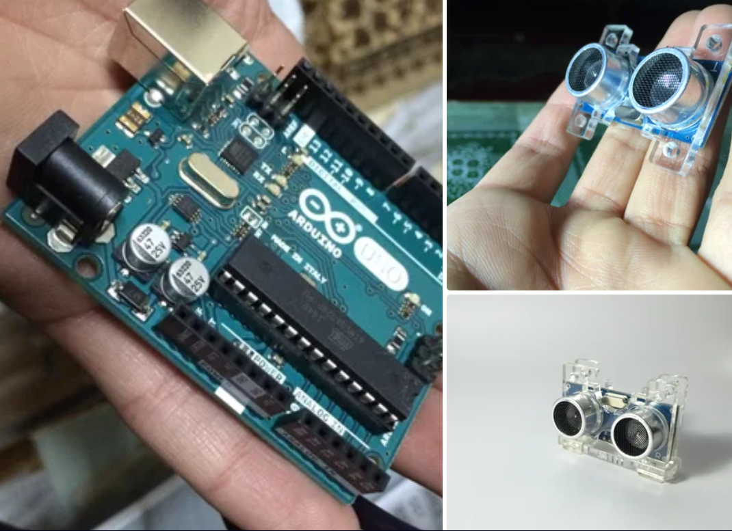

Wiring

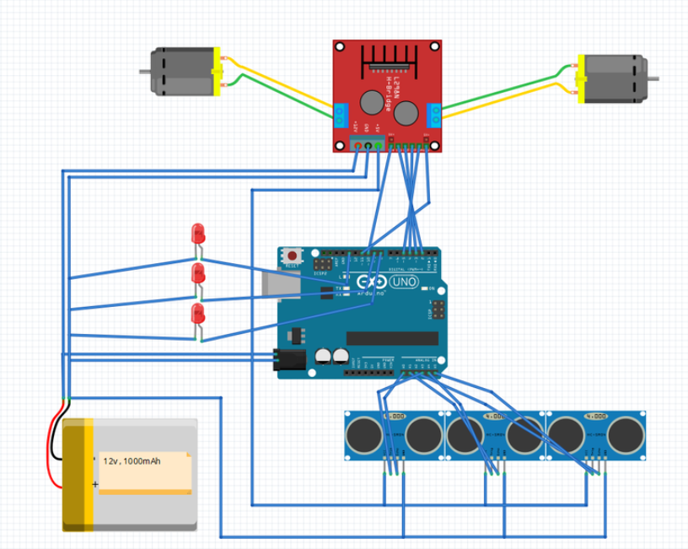

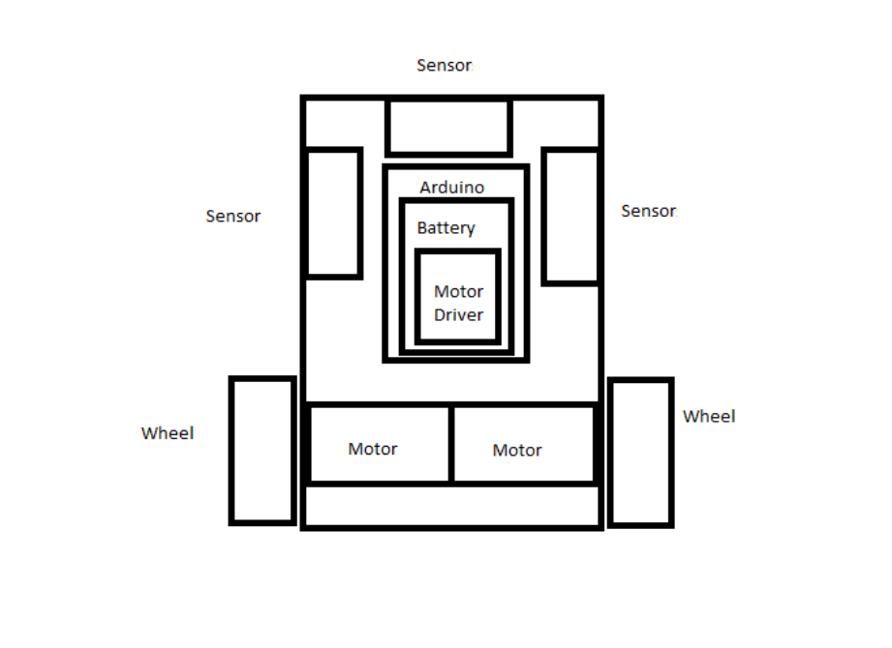

**Basic Bot Schematic**